**Replace the lost ssh key pair of the EC2 instance:**

We can replace the lost ssh key pair by creating the AMI of that instance for which the key is lost. Now create the instance from that AMI, now a new key is generated. Stop the previous instance.

* Create an instance in Ec2, and create the keypair
* 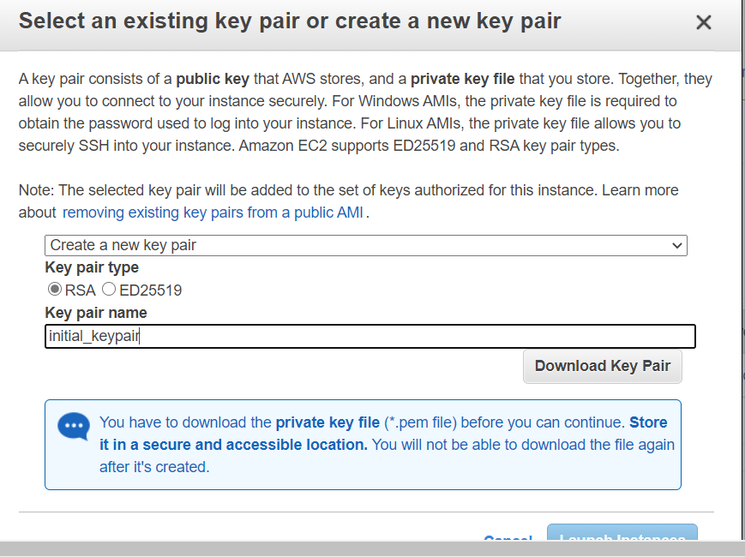
* Connect to the instance created
* Create a file to verify
* touch file.txt
* Add the text and save it .
* Cat file.txt to check the data

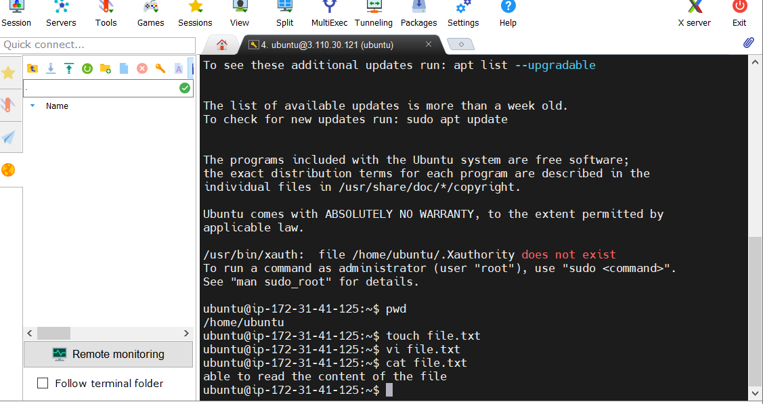

Now delete the created keypair in EC2 instance

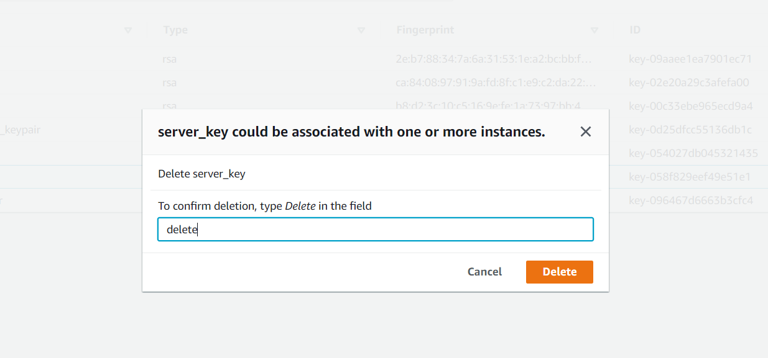

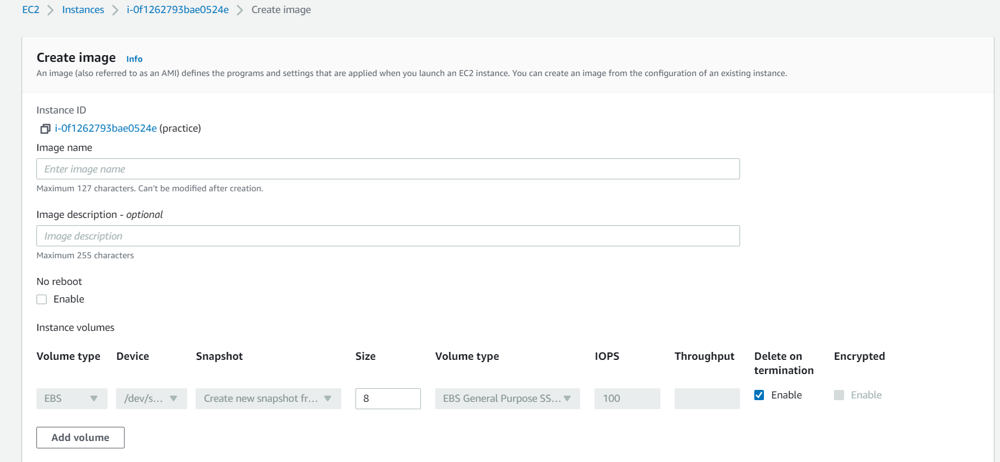

Now create the new key pair and connect to this instance

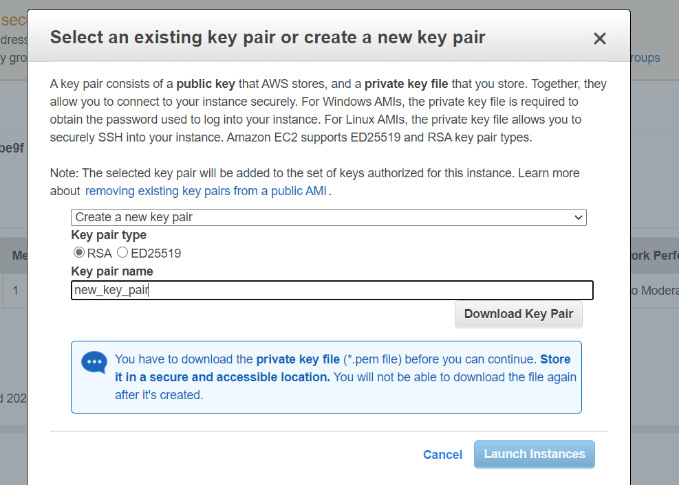

Now check the file we have created is present or not.

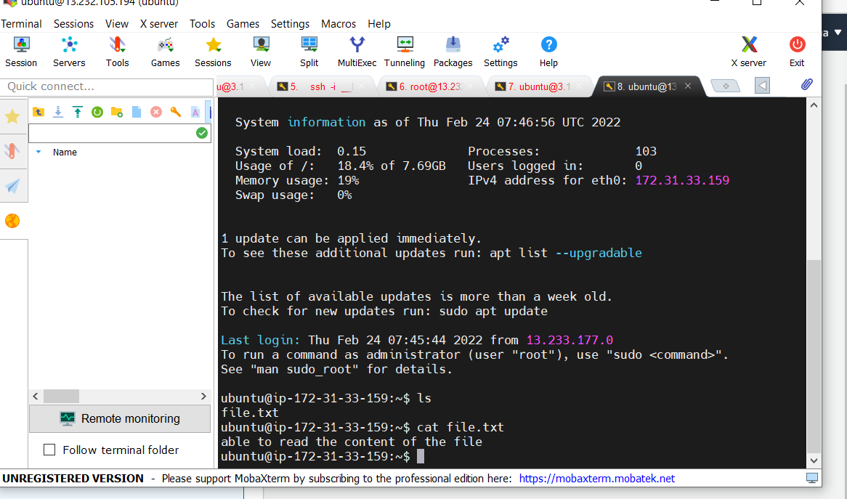

We can recover the instance for the lost keypair by creating the AMI of that instance.

**ADD AN EXTRA VOLUME TO THE EXIXTING RUNNING INSTANCE**

* First create an EC2instance
* Launch the AWS instance with 8gb volume
* Connect to the instance and check the volume before attaching the extra volume
* df -h (will have the initial volume shown)
* go to aws- volumes - create volume

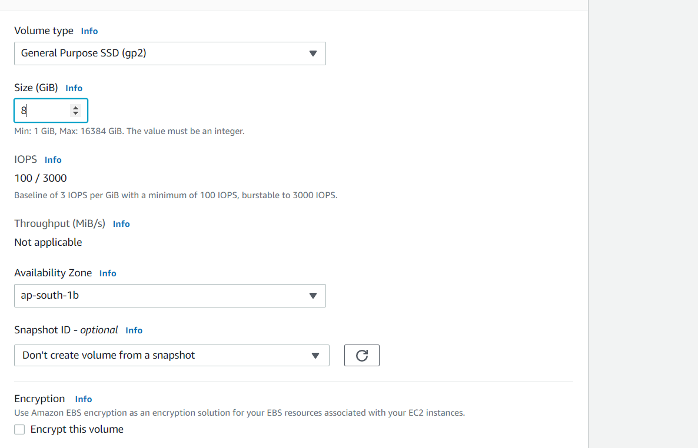

* Make sure that if you want to attach that volume to ec2 instance we have to launch in same available zones where the ec2 instance has launched

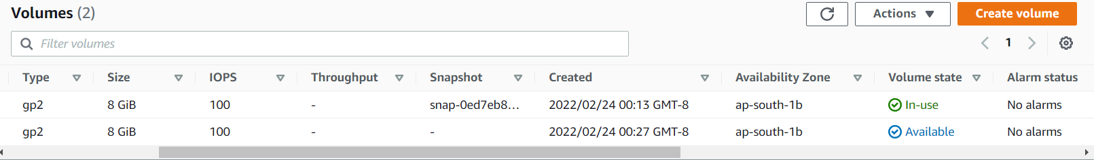

New volume is created , before mounting to the initial instance it will show as available

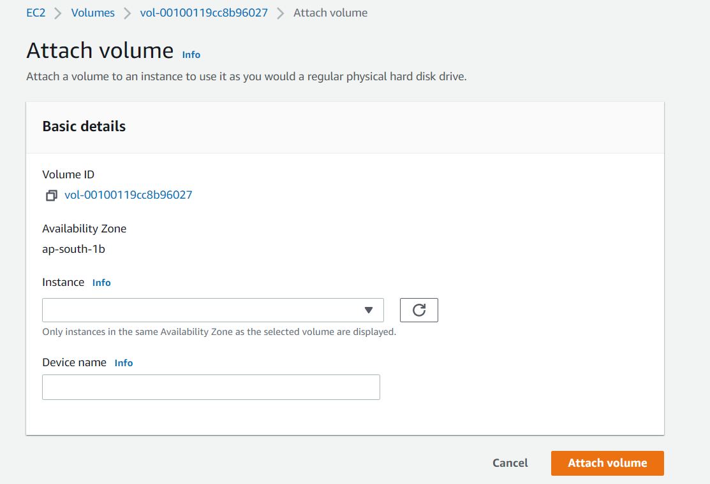

Here give the instance to which that volume is to be attached and click attach volume

Now the state of the volume created will change to in use.

In cli run the following commands to mount the extra volume

Check whether the disk contains any data or not by using the command

* Sudo file -s /dev/xvdf

Convert into ext4 format—

* sudo mkfs -t ext4 /dev/xvdf
* sudo mkdir /newvolume

But when created a new directories we have to mount that by the command

* sudo mount /dev/xvdf/ /newvolume

Now check the disk memory by using df -h

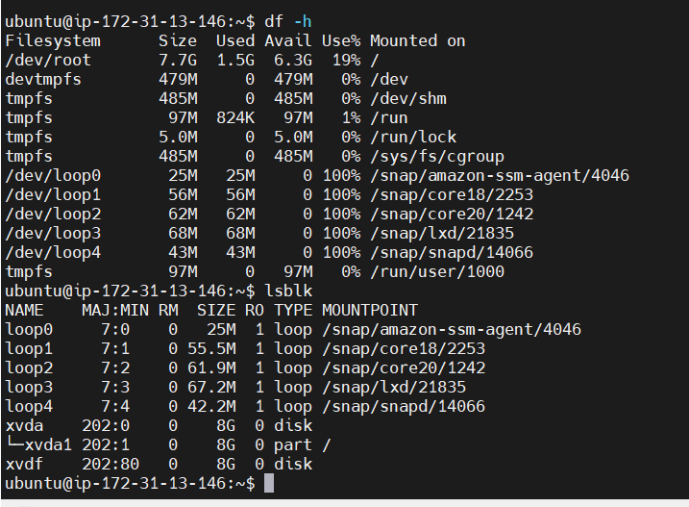

Now go to the instance and check whether the volume has been attached or not.

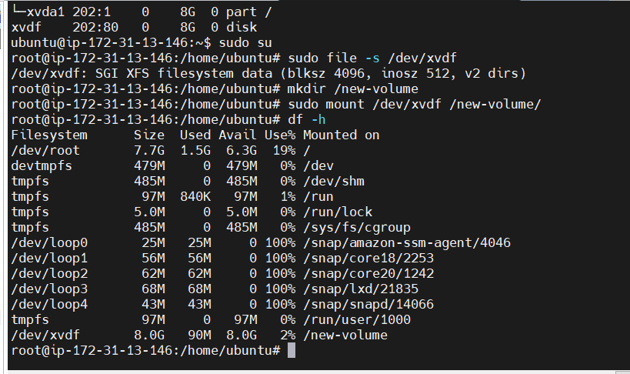

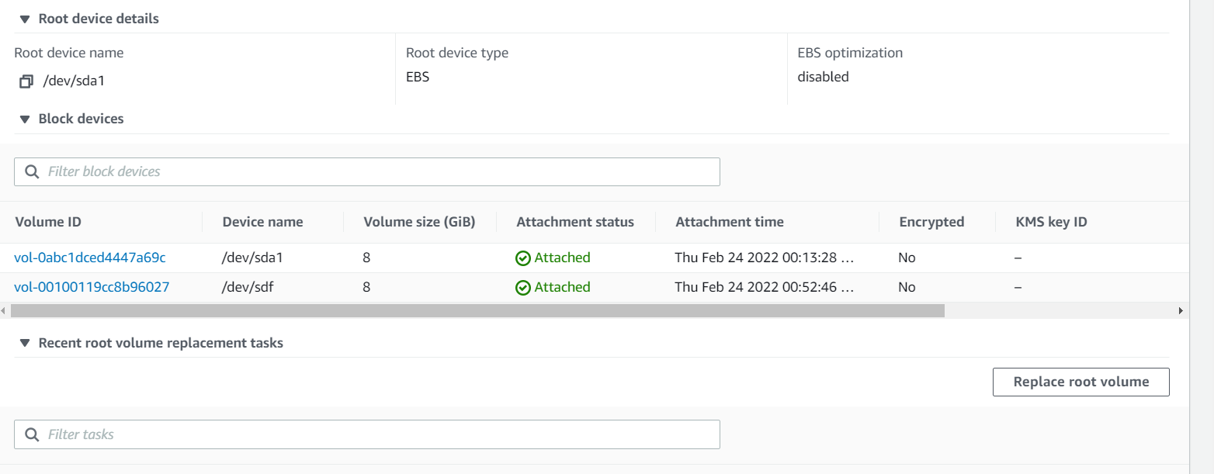

**Create snapshot of the root volume and attach to another instance**

Launch the new instance , , add 8gb storage

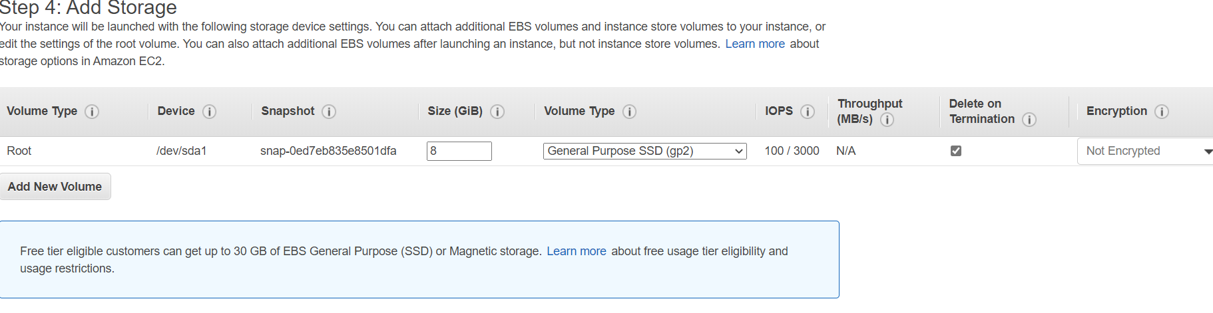

Create snapshot for the instance created

We can create using the instance id or volume id, and click create snapshot

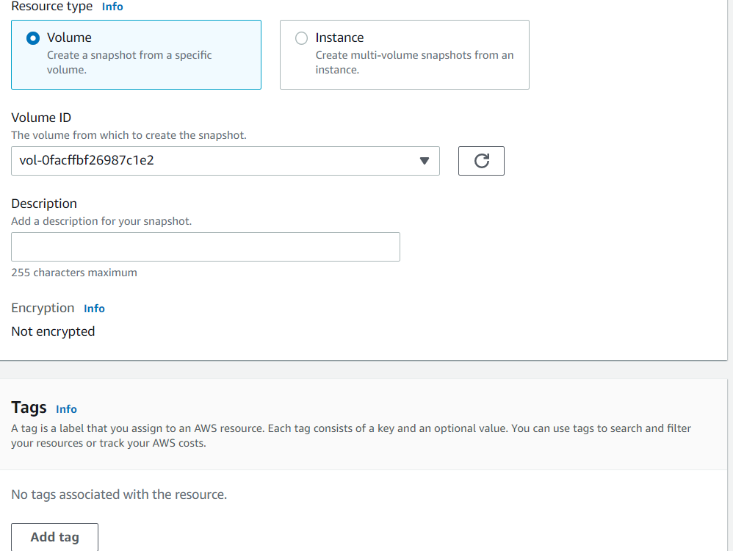

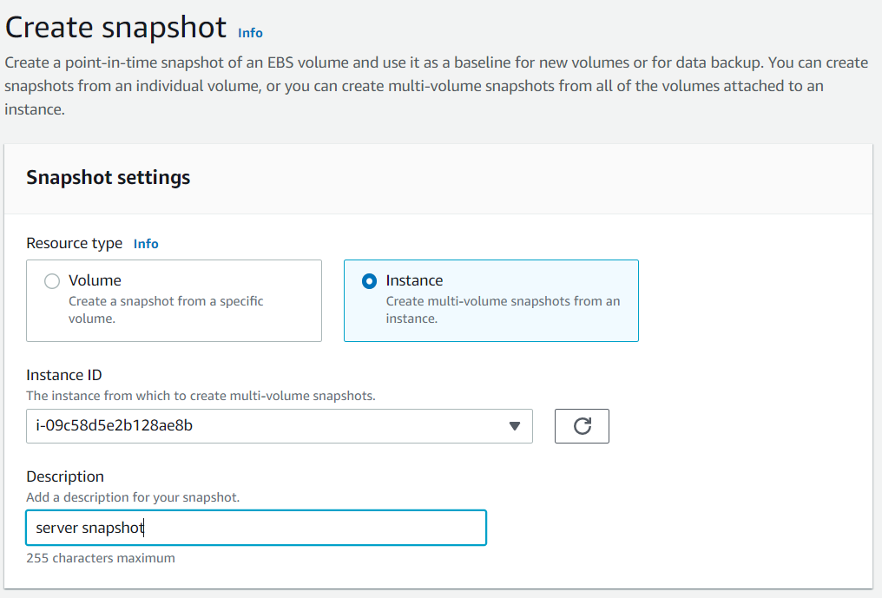

Snapshot is created

